Big Mart Sales Analysis
Name:- ABHISHEK
INTRODUCTION:-
Customer Satisfaction and keeping up with the demandfor products is very important for any store to survive in the market.Many businesses and enterprises keep track of the statisticaldata of their products so as to analyze their future demand in the market.The aim of our project is to build amachine learning model which can predict the sales of a product and understand its patterns and trends which is an important part of a big mart’s management.
VARIABLE | DESCRIPTION
Item_Identifier | Unique product ID
Item_Weight | Weight of product
Item_Fat_Content | Whether the product is low fat or not
Item_Visibility | The % of the total display area of all product in a store allocated to the particular product
Item_Type | The category to which the product belongs
Item_MRP | Maximum Retail Price (list price) of the product
Outlet_Identifi er | Unique Store ID
Outlet_Establishment_Year | The year in which store was established
Outlet_Size | The size of the outlet in terms of ground area covered
Outlet_Location_Type | The type of city in which the store is located
Outlet_Type | Whether the outlet is just a grocery store or some sort of supermarket
Item_Outlet_Sales | Sales of the product in the particular store This is the outcome variable to be predicted.
DATA AND SOURCES OF DATA:-

Access link
(https://drive.google.com/file/d/1C0679Uk1EUrPgFxXZOg1wmqRan1TsujR/view?usp=sharing)
No. Of rows and Columns: 8523 rows × 12 columns

The data which was required for the project is collected from a Kaggle Dataset. The dataset set contains certainattributes like:-

DATA PROCESSING AND METHODOLOGY
A. Data Cleaning and Preprocessing:-
The collected data is passed through a ‘cleaning’ process, so as to make sure that the data is segregated properly and identified gaps in the data are filled with the appropriate information, making data compatible and also fixing errors in storage systems which can cause data redundancy.

B. Data Modeling:-
This is primarily a process in which the given dataset and the objects in it are analyzed to get a clear view of the requirements that may help us support our business model. Based on the analysis on patterns present in the data, models are then created on the established flow of the project. This flow offers a better assistance in the utilization of the previously agreed upon semi-formal model that showcases the features of the project. It also provides guidance to follow the relation between the data objects and other objects.

C. Data Prediction:-
Machine Learning prediction models are trained in thisprocess and then later on evaluated using the data. This will then be applied to the preprocessed dataset. Some of the Models to be used for the prediction are:-
a).Linear Regression:-
Linear regression is a supervised machine learning algorithm that is the most commonly used predictive analysis. This Regression model defines the relationship between the dependent as well as the independent variable.Thedependent variable is also known as the response variable and can be denoted by X. The Independent variables are an input factor and are also known as the explanatory or predictor variables and can bedenoted as Y in this case. The equation for LinearRegression is as follows:-Y= a+bX
mean_absolute_error:- 477.9858904633177
r2_score:- 0.5829985235005208
RMSE value:- 599.4950981614279
The above graph shows us d/f b/w Actual vs Predicted Data by linearregression:-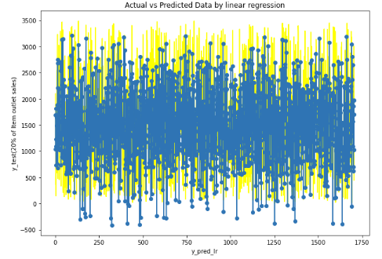b). Random Forest :-Random forest is a Machine Learning algorithm that is used for classification as well as regression problems. This ML algorithm combines multiple decision trees together to create a model that has high accuracy and more stability. Rather than depending on just one decision tree algorithm, the random forest takes the predicted outcome from each tree and also analyses the majority votes of predictions, and predicts the final output.
mean_absolute_error:- 417.9643988269795
r2_score:- 0.6536310037610501
Rmsevalue:- 546.369371481759
The above graph shows us d/f b/w Actual vs Predicted Data byRandom forest:-
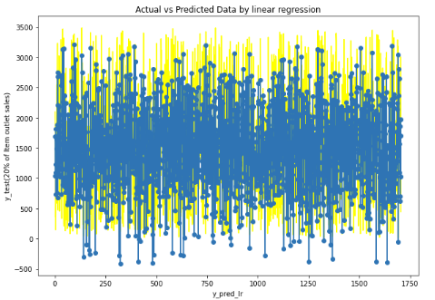
D. Data Visualization:-
Data Analyzed is then further picturized for customers and the admin to reach out conclusions and take effective decisions. A).(Show no. of Item type in Item fat content)b).(showing the size of items )
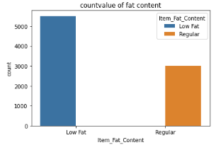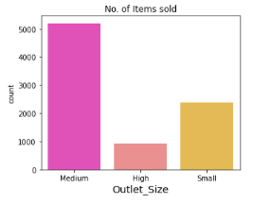

c).(Distribution of the variable outlet_size)d). (Outlet Establishment Year and Item Outlet Sales)
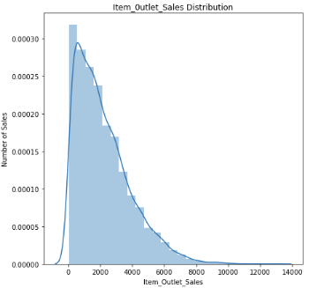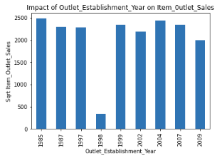

E). (Graph of highest sale value)
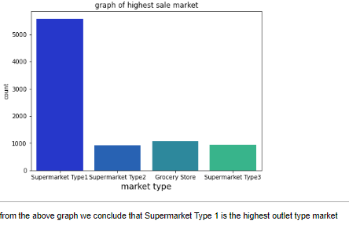

Step used in jupyter notebook for predict sales:-
1). Data cleaning.
2). Data Visualization.
3). Preprocessing task before model building.
a). label encoding.
b).splitting our data into train and test.
c).standardization.
d).model building.
4) Evaluation using Linear regressor.
5) Evaluation using random forest regressor.
6) Actual vs Predicted sales graph.

EVALUATION METRICS:-
Evaluation metrics are an important part while building an efficient machine learning model. It helps to get suggestive results about the model which can be compared and improved till we achieve good accuracy. Evaluation metrics are a way to concentrate on a model’s results and have the ability to distinguish between model outcomes. In our project, we have used the,mean_absolute_error,r2_score,Root Mean Squared Error (RMSE) metric for the evaluation.
a). mean_absolute_error,r2_score ,Root Mean Squared Error (RMSE) in linear regressor :-
mean_absolute_error:- 477.9858904633177
r2_score:- 0.5829985235005208
RMSE value:- 599.4950981614279

b). mean_absolute_error,r2_score ,root_mean_squared_error(RMSE) in Raandom forest:-
mean_absolute_error:- 417.9643988269795
r2_score:- 0.6536310037610501
Rmsevalue:- 546.369371481759

Results:-
Name | r2_score | Root Mean Square Error (RMSE) value. | mean_absolute_error
Linear Regression | 0.5829985235005208 | 599.4950981614279 | 477.9858904633177
Random Forest | 0.6536310037610501 | 546.369371481759 | 417.9643988269795

CONCLUSION:-
We have applied two algorithms Random Forest Regression, Linear Regression . From the results, we can conclude that among all the four algorithms Random Forest has the highest r2_score of 0.6536 when distinguished together.The R2_score which is nearer to 1 is consider to be good. Thus, we can say that Random Forest is the better algorithm than Linear Regression for efficient sales analysis.

TOOLS USED:-
POWER BI:
Power BI is a Business Intelligence Tool which is used by many companies.This tool Provide us the whole information regarding the dataset via Graphs, Reports.
